Creating EC2 Instances within Custom VPC

Create VPC:

VPC is a virtual network that closely resembles a traditional network that you'd operate in your own data center.
Create a VPC (Jenkins-vpc) with CIDR 10.0.0.0/24 or with any CIDR range.

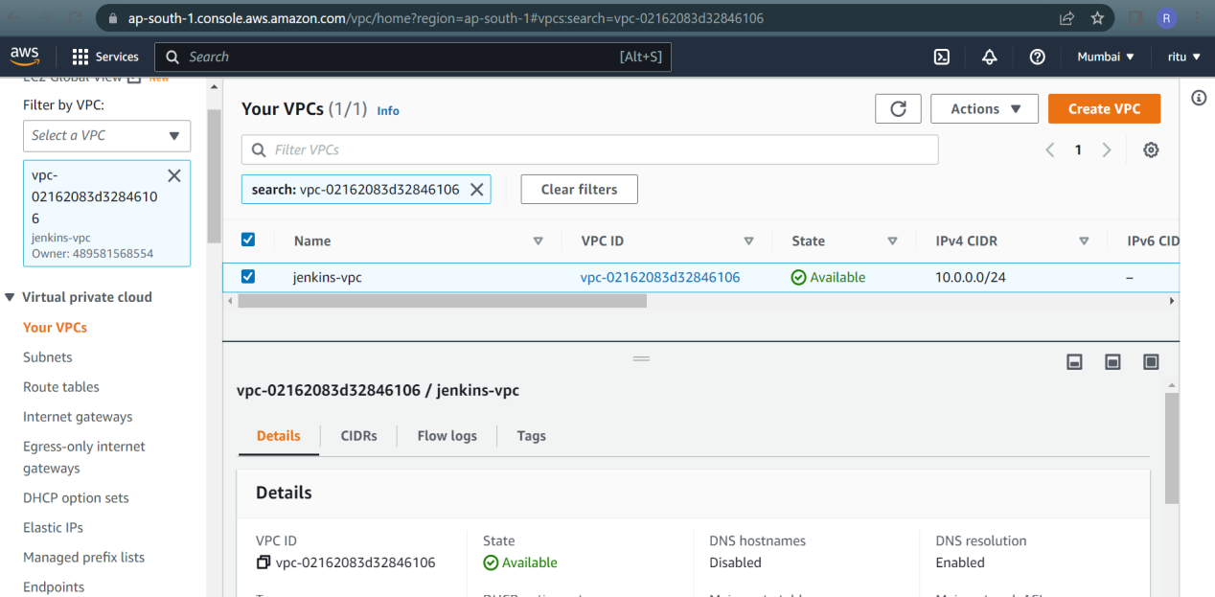

Create Subnet:

A Subnet must reside in a single Availability Zone.
Create a Subnet within the CIDR of VPC

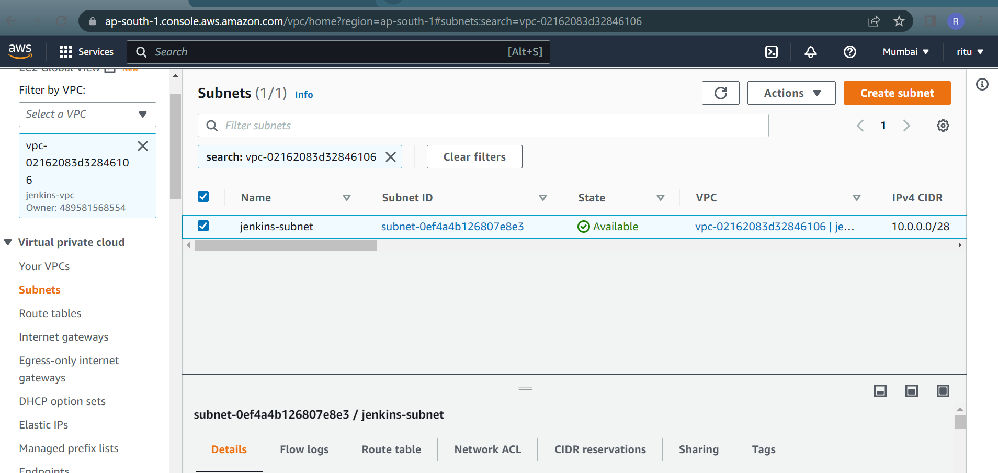

Create Internet Gateway(IGW):

An internet gateway is a horizontally scaled, redundant, and highly available VPC component that allows communication between your VPC and the internet.
We need to configure IGW to get internet to VPC.

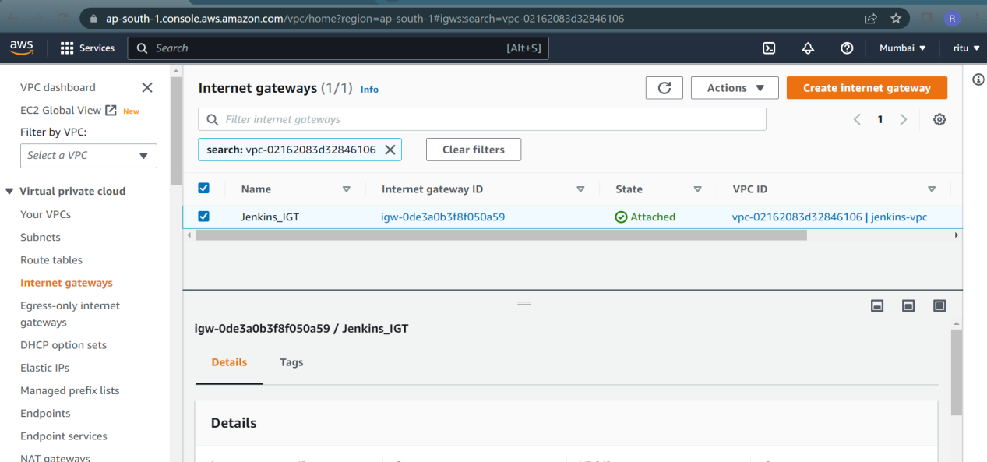

Create Route table:

The route table contains existing routes with targets other than a network interface, Gateway Load Balance endpoint, or the default local route.
Create new route Table make sure that select right VPC.

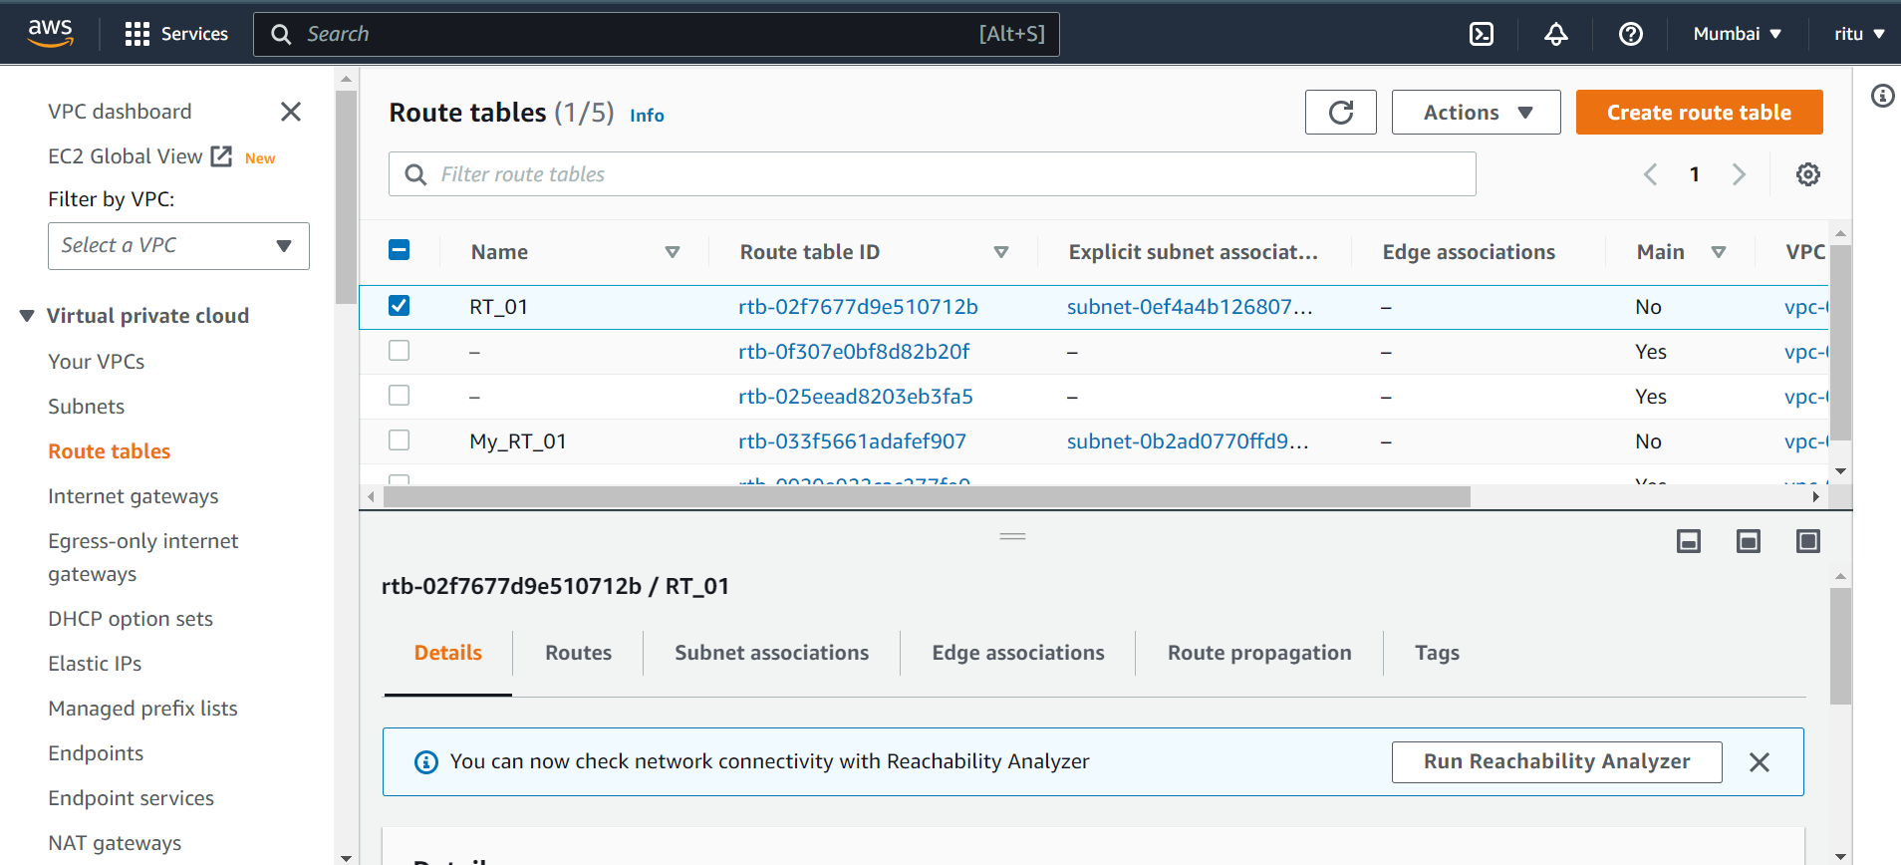

Associate this route table with the Subnets

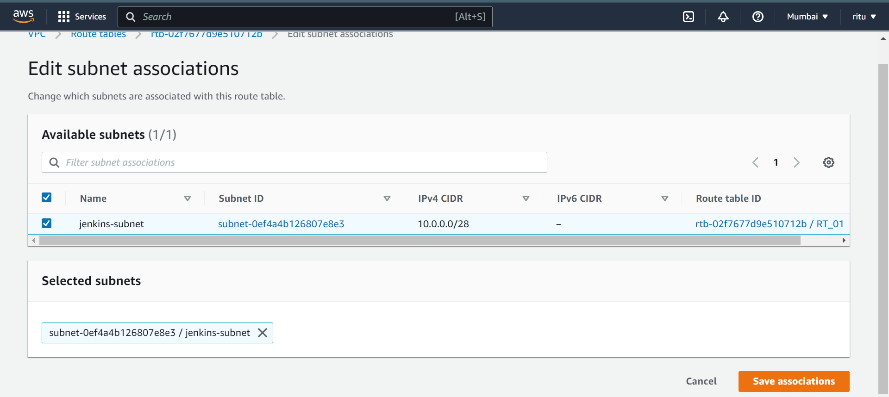

Add route for the Internet by default route table have an entry only for this local VPC. Want to enable the traffic end flow internet that’s way edit this route table and add destination for the internet and route it to internet gateway.

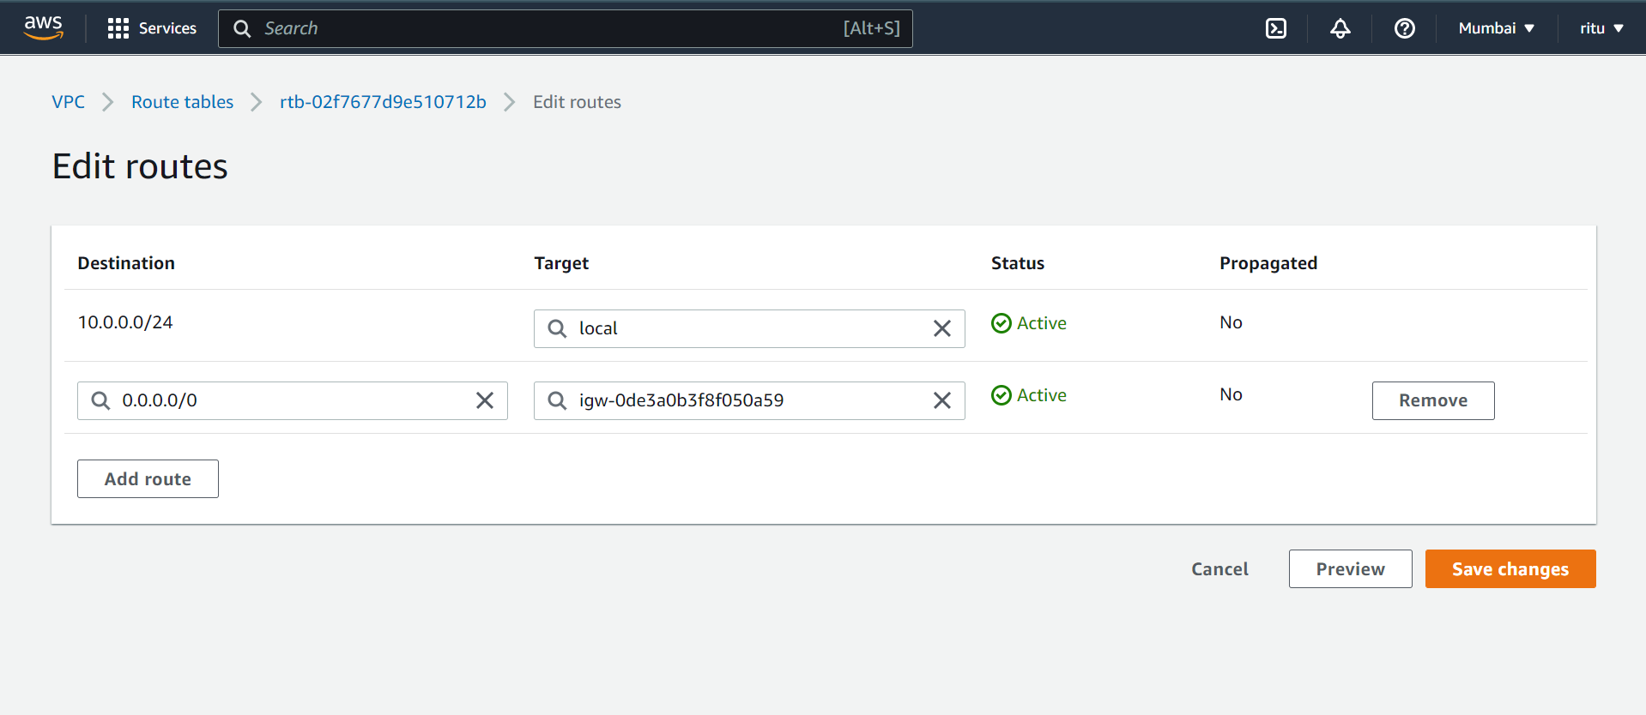

Launch EC2-Instances(Windows):

Created Two Ec2 Instances windows with same VPC

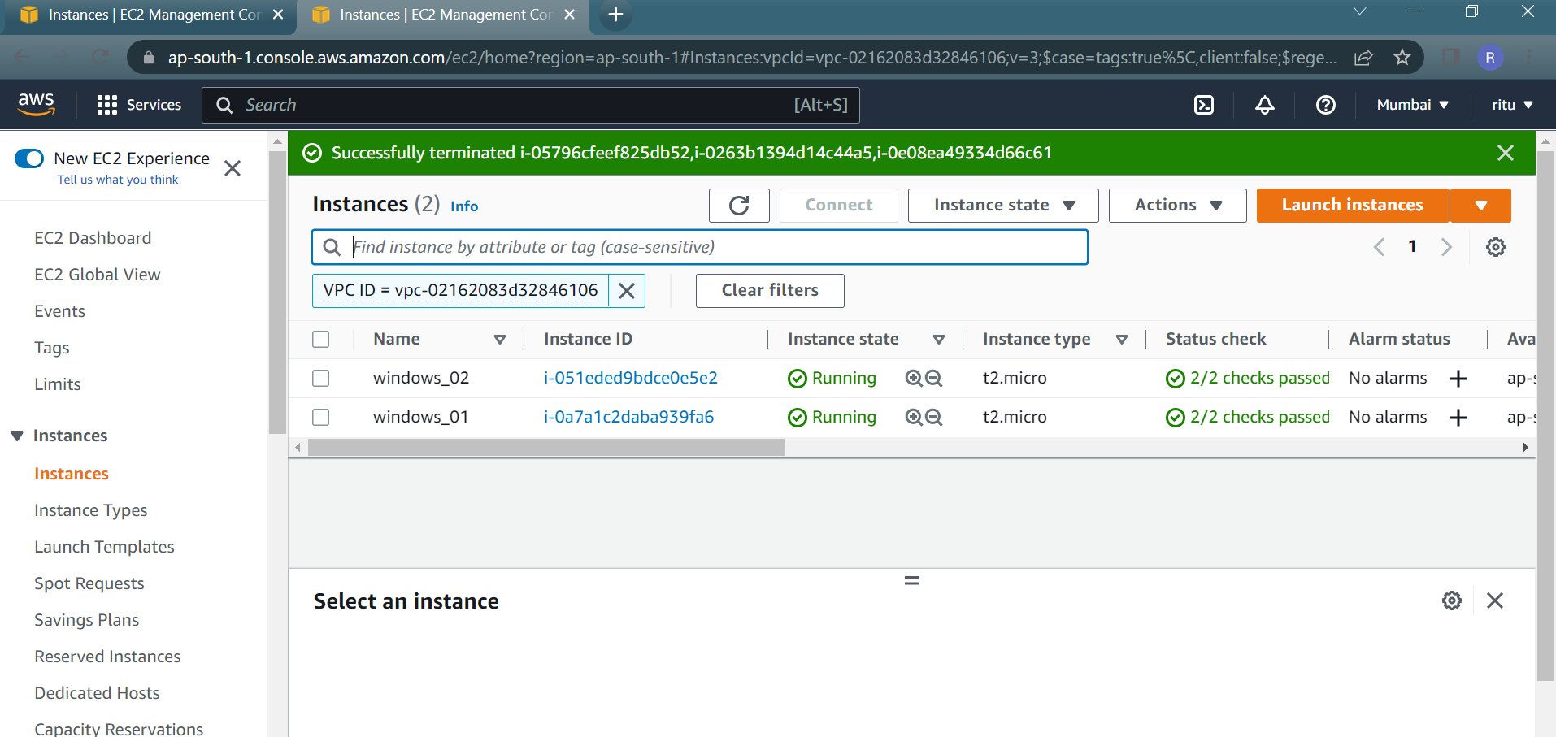

Windows Instances are launched within VPC and launched successfully.

